The Junior Entrepreneur Programme is a unique programme in which children create entrepreneurial businesses in primary schools around Ireland.  Each child creates an individual business idea. This is presented to the child’s group. The group then picks & develops the individual idea which it feels is best to present to the Dragons as the group idea. The Dragons select the “Big Idea” which the class must turn into reality.  Business people visit the classroom to offer practical advice & share their own business stories. The children research their “Big Idea.” They learn about surveys & study their market. They pool their skills & talents to form teams based on design and production, marketing, finance, storytelling & sales. They invest their own money in their business & offer real products created from scratch to real customers who pay for what they have produced. The children’s inspiration & dedication over 10-12 weeks come together on Showcase Day, 24 March 2017.  We hope that you will join us. | In the interests of reducing waste, we ask you to email orders to gloriousgifts2017@hotmail.com. Alternatively, please print out our brochure only if you wish to place a paper order with “Glorious Gifts.” Please list below what you wish to purchase and we will prepare your order in advance of Showcase Day.  ________________________________________________________________________________________________________________________________________________________________________________________________________________________________________ | Name and Contact Number: __________________________________________________________________________________ | Glorious Gifts  Showcase Day:  24 March 2017  5th Class Junior Entrepreneur Programme  2016-2017

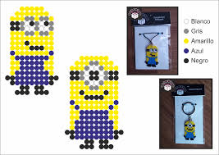  Hama Bead Keyrings  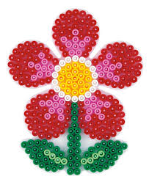  Hama Bead Fridge Magnets | Our “Big Idea” for business is handmade Hama bead crafts & customised bookmarks. Our gifts are designed & created by children. Every child in 5th Class is proud of Glorious Gifts.  Customised Bookmarks  Dare  To  Dream!  Focus on What You Do Best  You might try a summary of competitive benefits at left and a brief client success story or some of those glowing testimonials here in the middle. | A guide to prices:  Prices of individual items will depend upon the amount of time and effort spent on their production as well as upon the cost of their construction. Bookmarks will sell for €1.00-€1.50 and Hama crafts from €2.00-€5.00. A small number of Hama crafts will be on sale for €1.00. We hope that you will support us on 24 March.  For their advice, support and assistance with our JEP project, we would like to thank:  - Mr. Connor  - Mrs. Mc Connell  - Mr. Eugene O Mara  - Mr. David Gross  - Mr. Morgan Brown  - Mr. Karl Naylor, Hunt Security  Contact Us  St. Mary’s and St Gerard’s N.S.  Enniskerry  Email: gloriousgifts2017@hotmail.com

