The Junior Entrepreneur Programme is a unique programme in which children create entrepreneurial businesses in primary schools around Ireland.  Each child creates an individual business idea. This is presented to the child’s group. The group then picks & develops the individual idea which it feels is best to present to the Dragons as the group idea. The Dragons select the “Big Idea” which the class must turn into reality.  Business people visit the classroom to offer practical advice & share their own business stories. The children research their “Big Idea.” They learn about surveys & study their market. They pool their skills & talents to form teams based on design and production, marketing, finance, storytelling & sales. They invest their own money in their business & offer real products created from scratch to real customers who pay for what they have produced. The children’s inspiration & dedication over 10-12 weeks come together on Showcase Day, Thursday 15 March 2018.  We hope that you will join us. | In the interests of reducing waste, we ask you to email your order to perfectpresents2018@hotmail.com. Alternatively, please print out our brochure only if you wish to place a paper order with “Perfect Presents.” Please list below what you wish to purchase and return it to us before Thur, 8 Mar. We will endeavour to prepare your order in advance of Showcase Day.  ________________________________________________________________________________________________________________________________________________________________________________________________________________________________________ | Name and Contact Number: __________________________________________________________________________________ | Perfect Presents  Showcase Day:  15 March 2018  5th Class Junior Entrepreneur Programme  2017-2018  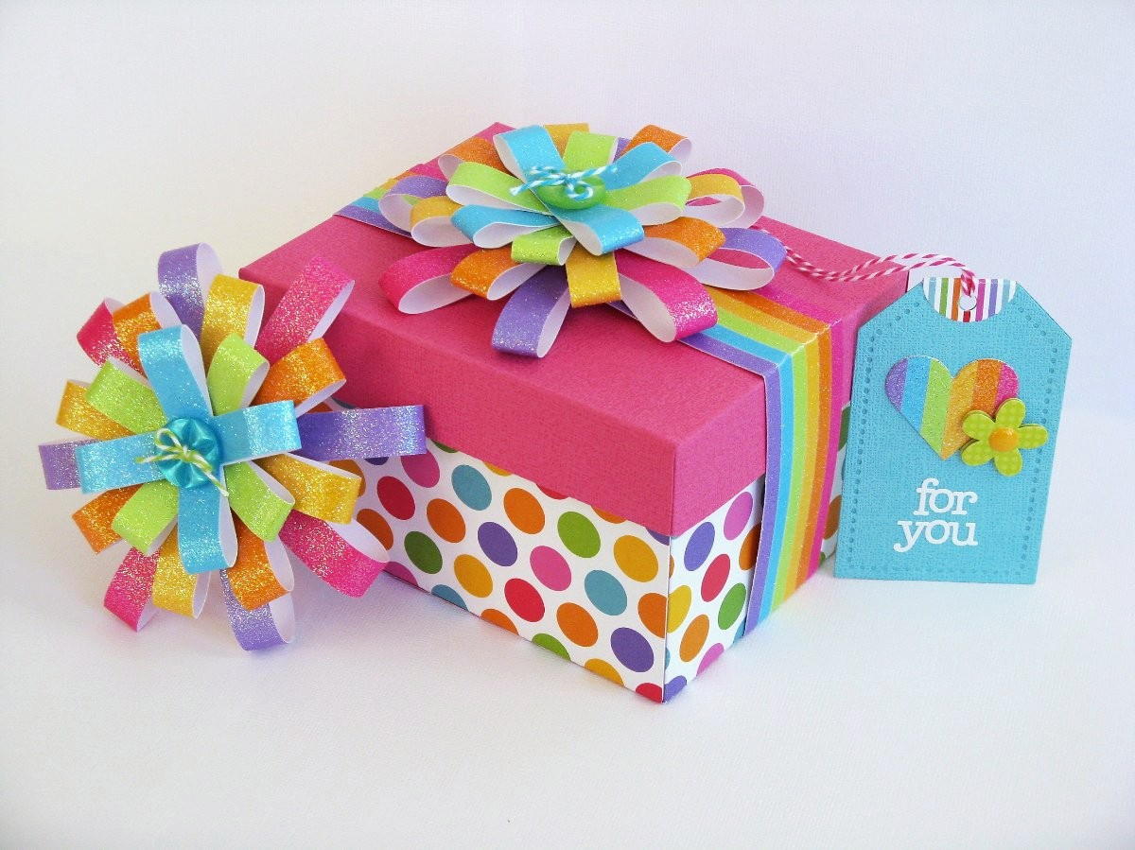  perfectpresents2018@hotmail.com

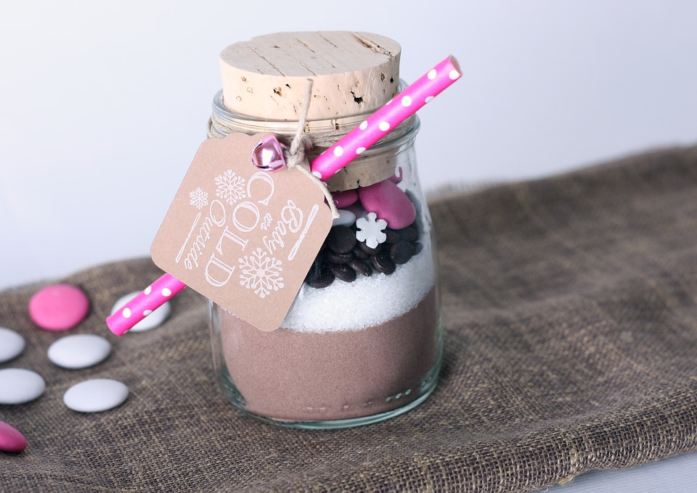  Hot chocolate and marshmallow mix  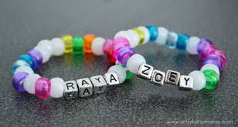  Pony bead bracelets or necklaces: we can add names, sets of initials or messages on items ordered in advance | Our “Big Idea” for business is handmade and customized bead crafts, chocolates, drinks and sockmen. Our gifts are designed and created by children. Every child in 5th Class is proud of Perfect Presents.  Sockmen: light & dark colours  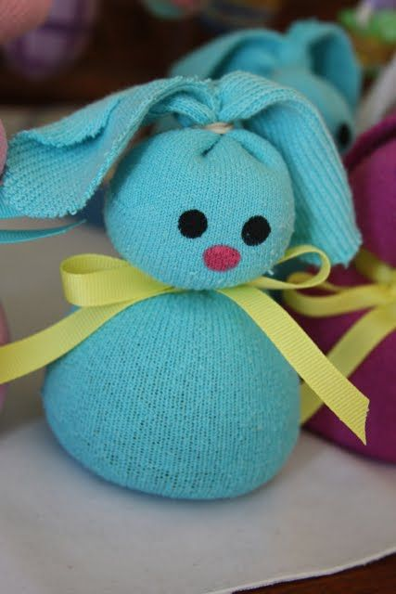  Handmade chocolates: Milk, dark & white with/without sprinkles  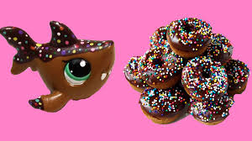 | A guide to prices:  Prices of individual items will depend upon the amount of time and effort spent on their production as well as upon the cost of their production. Hot chocolate & marshmallow mixes will sell for €2-€3 (depending on size); bead crafts from €1-€3; sockmen for €2-€3; origami bags for 20c-€1; & chocolates (milk, dark & white) for 50c-€1. We hope that you will support us on Thur. 15 March.  For their advice, support and assistance with our JEP project, we would like to thank:  - Ms. Langan  - Mrs. Mc Connell  - Mrs. Russell  - Morgan Browne  - Dee Browne  - Mrs. Orla Redden and The Property Shop  Contact Us  St. Mary’s and St Gerard’s N.S.,  Enniskerry.  Email: perfectpresents2018@hotmail.com  Final date for orders:  Thursday 8 March

