January Newsletter
St. Mary’s & St. Gerard’s
Recent Events

January 14
Music in the Classroom

January 24
JEP (Junior Entrepreneur Programme).

January 24
Touch Rugby

Music in the Classroom
On Monday January 14th and Tuesday 15th, the students from 3rd and 4th class were in the National Concert Hall Earlsfort Terrace for a performance by the RTE Symphony Orchestra conducted by Gavin Maloney. The concert was presented by Tom Redmond.
The children joined with the orchestra and a concert hall full of students from other schools to form a huge choir to sing ‘Charleston Champions’, which they had rehearsed in school.
It was extremely enjoyable trip which no doubt inspired the students.

Touch Rugby
5th and 6th class have begun touch rugby and will be doing it for ten weeks.

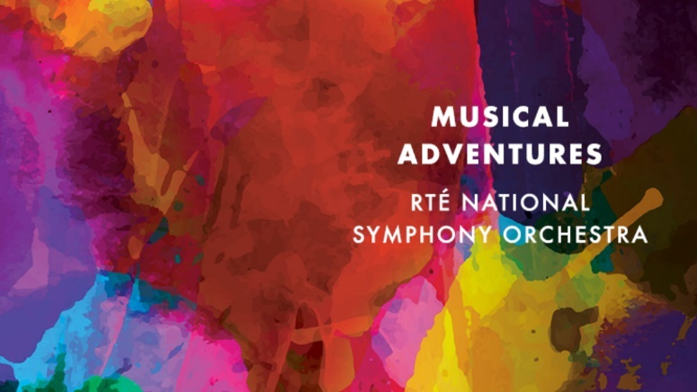

More Important News
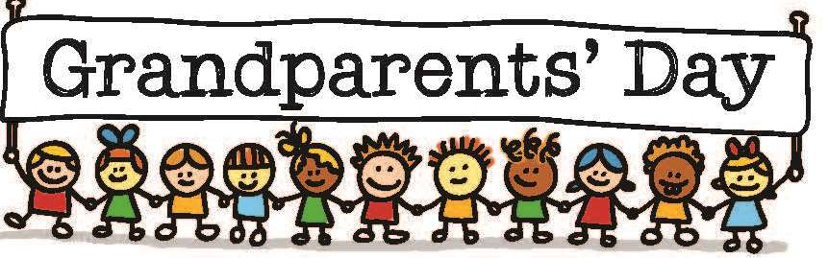
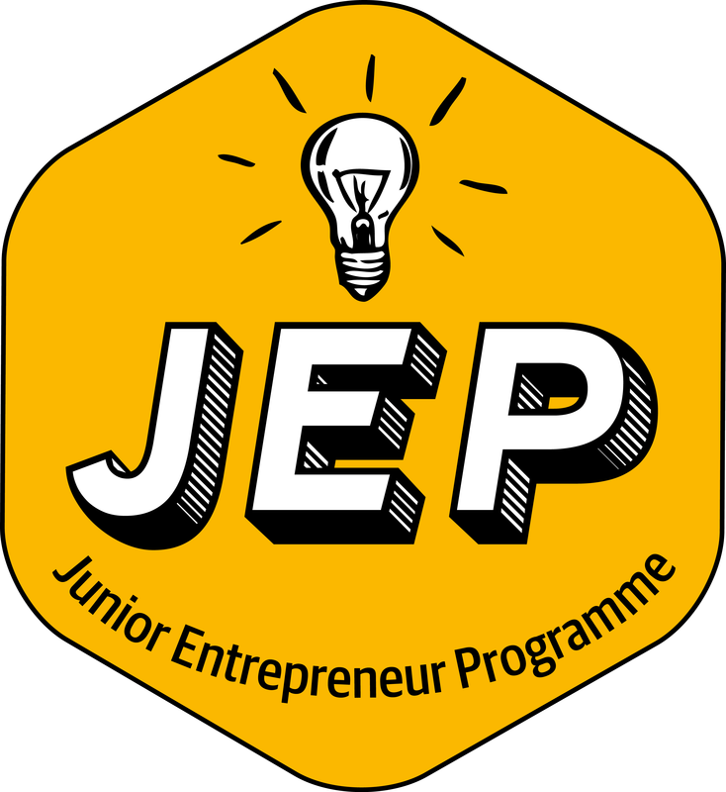

Grand Parents Day/Special Family Member Day 2019
The school are delighted to have another Grandparents Day on February 1st.
Every year the children of the school invite their Grandparents or a special family member such as an Aunt, Uncle or Godparent. It’s also a day to remember grandparents who couldn’t attend too. The event will begin with a mass at St Mary’s Church then followed by tea, coffee and snacks in the school.
Guests are then invited up to the children’s classroom to interact with the class and share past school memories. It is always a huge success and is enjoyed greatly by the children and invited guests.

JEP – Junior Entrepreneur Programme
The children of 5th class take part in the Junior Entrepreneur Programme. The children come up with ideas of items they can make and sell to other children and family members of the school. This is a great opportunity for children to test out their entrepreneur skills and learn what it’s like to run their own business.

